3SDW AQ/AQRV DATA PACKAGE DESCRIPTIONS

Draft: 8/26/2014

The Three State Data Warehouse (3SDW) is a repository of air quality data related modeling, evaluation and visualization tools developed cooperatively by the Environmental Protection Agency (EPA) Region 8, Forest Service (FS), National Park Service (NPS), and Bureau of Land Management (BLM) and State agency offices in Colorado, Wyoming, and Utah State Offices.

The 3SDW offers pre-defined, cooperator approved, NEPA modeling data packages to support consistent AQ/AQRV Photochemical Grid Model (PGM) analysis for NEPA related projects, and the 3SDW also offers additional PGM resources for less constrained non-NEPA analysis that may support other regulatory, research or academic applications. General descriptions of air quality modeling data resources available through the 3SDW are outlined below.

NEPA DATA PACKAGE

The NEPA air quality modeling resources and data packages have been designed, in part, to help ensure project consistency, comparability and transparency for NEPA related projects in this region. These packages have been pre-defined and cooperator approved to support NEPA AQ/AQEV air quality modeling applications (specifically CAMX and CMAQ modeling), and include:

- Base-case and future no-action model output along with Meteorological and PGM Model Performance Evaluation (MPE) reports for each scenario
- Files and processing tools to create model-ready future-case project emissions (e.g. additional O&G wells)
- Model-ready future-case emissions files for sources that do not require project level changes (e.g. boundary conditions, other anthropogenic sources and natural emissions)
- Model-ready future-case meteorological files
- Configuration instructions and additional support files to run a future-case model
- Quality assurance test instructions and bench-marching recommendations for user generated results
- Model result processing tools/scripts to enable comparison of user generated future-case modeling results with 3SDW provided base-case and future no-action results

Additional information regarding 3SDW support of a NEPA process is contained in the 3SDW NEPA AQ/AQRV Process Outline, and additional information about each specific NEPA data package is available through the 3SDW in package specific Data Manifest files.

Additional NON-NEPA DATA PACKAGE resources

In addition to the pre-defined NEPA data packages, additional less constrained PGM modeling resources will be available through the 3SDW for other purposes including regulatory, research, and academic applications. Some specific resources that may be available include:

- Meteorological data processing tools (e.g. WRF and GEOSCHEM configuration and support files)
- Emissions data processing tools (e.g. SMOKE configuration and support files)

Currently, model evaluation tools only support review of the base case and future no-action case NEPA scenarios, but later versions of the 3SDW may be able to support user uploads of modeled data results, and evaluation of results using 3SDW visualization and summary tools.

Implementation Notes:

Data Request Form (Dustin’s mock-up):

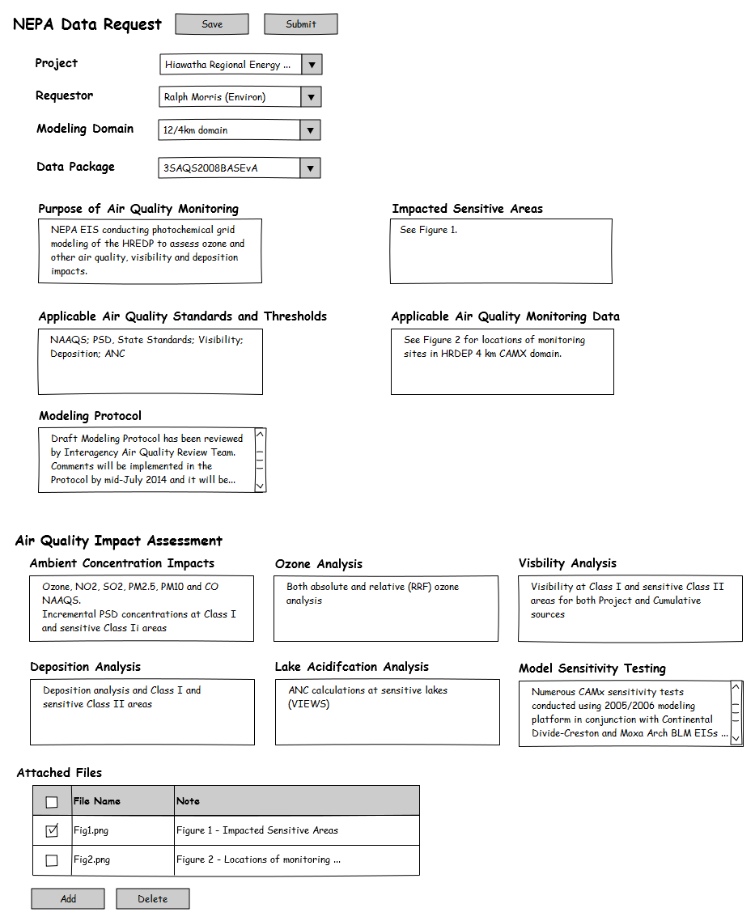
*Add NEPA/non-NEPA selection option
*Add option to include separate O3 RRF package for NEPA selection
Development Notes:

A Project set-up form is being developed which will be used to “register” a project with some project tracking information. A data request form can reference any registered project.

The selection of a NEPA package returns only one package based on the Base/Future year modeling platform selection. Selection of a non-NEPA selection will prompt additional data download options for model file types. The attached spreadsheet is a draft effort to define the contents available for non-NEPA data packages

Next steps – need project descriptions and data needs to implement a non-NEPA project support example

